 | 
COUNCIL ASSESSMENT REPORT – MODIFICATION APPLICATION
HUNTER AND CENTRAL COAST REGIONAL PLANNING PANEL

PANEL REFERENCE & DA NUMBER | PPSHCC-371 – DA/2294/2021/A
PROPOSAL | Seniors housing – modification
ADDRESS | 1B Glover Street, Belmont (formerly known as 2A Maude Street, Belmont)  Lot 202 DP 1236307
APPLICANT | ADW Johnson
OWNER | Oak Tree Retirement Village Belmont Pty Ltd
MOD LODGEMENT DATE | 21 May 2025
ORIGINAL DA DETERMINATION DATE | 1 June 2022
APPLICATION TYPE | Modification Application under Section 4.55(2)
REGIONALLY SIGNIFICANT CRITERIA | Section 2.19(1) and Clause 2 of Schedule 6 of State Environmental Planning Policy (Planning Systems) 2021 declares the proposal regionally significant development as general development over $30 million.
ESTIMATED DEVELOPMENT COST (EDC) | $73,685,000 (excluding GST) – modified EDC  $34,362,842 (excluding GST) – original CIV
CLAUSE 4.6 REQUESTS | This is a modification and clause 4.6 does not apply.  The original application included an approval for an exception to a development standard in Lake Macquarie Local Environmental Plan 2014 Clause 4.3 Height of buildings development standard of 10m.  The modification application is requesting approval for additional building height.
KEY SEPP/LEP | State Environmental Planning Policy (Planning Systems) 2021  State Environmental Planning Policy (Resilience and Hazards) 2021  State Environmental Planning Policy (Transport and Infrastructure) 2021  State Environmental Planning Policy (Sustainable Buildings) 2022  State Environmental Planning Policy (Housing) 2021– Chapter 4 Design of residential apartment development  State Environmental Planning Policy (Industry and Employment) 2021  Lake Macquarie Local Environmental Plan 2014
TOTAL & UNIQUE SUBMISSIONS KEY ISSUES IN SUBMISSIONS | No submissions were received during notification of the modification application.
DOCUMENTS SUBMITTED FOR CONSIDERATION | - Attachment A: Draft conditions of consent  - Attachment B: Draft conditions of consent (track changes)  - Attachment C: Architectural plans  - Attachment D: Landscape plans  - Attachment E: Engineering plans  - Attachment F: Report on updated desktop groundwater assessment  - Attachment G: Dewatering Management Plan for construction  - Attachment H: Waste management plan
RECOMMENDATION | Approval
DRAFT CONDITIONS TO APPLICANT | Yes
SCHEDULED MEETING DATE | 28 October 2025
PLAN VERSION | Architectural plans 30 September 2025 Version No 13  Landscape plans 29 September 2025 Version No L  Engineering plans 29 September 2025 Version No B
PREPARED BY | Geoffrey Keech, Senior Development Planner
DATE OF REPORT | 21 October 2025

EXECUTIVE SUMMARY
DA/2294/2021/A at 1B Glover Street Belmont seeks approval for the modification of an approved seniors housing development.
The proposal increases the approved built form to four stories of independent living units, increases the basement and ground level carparking (127 spaces), and introduces a roof top terrace above the upper level of dwellings. The proposed height of buildings is 17.75m.
Pursuant to s4.55(2)(a) of the Environmental Planning and Assessment Act 1979 (EP&A Act) the development as modified is considered substantially the same as originally approved.
The application is referred to the Hunter and Central Coast Regional Planning Panel (HCCRPP) in accordance with s275(2) of the Environmental Planning and Assessment Regulation 2021 (Regulation) as it:
- constitutes a departure from the height of buildings development standard set by clause 4.3 of the Lake Macquarie Local Environmental Plan 2014 (LM LEP), and
- seeks to modify a condition imposed by the HCCRPP in its original determination, being the imposition of standards in relation to electric vehicle charging infrastructure.
Key issues considered in this assessment include:
- building height, bulk and scale
- traffic impact of increased dwelling yield
- retention of mature amenity trees
- design of parking and provision of electric vehicle charging infrastructure
- management of waste, and
- access for ambulance stretchers.
The application was notified and no submissions were received.
The application is integrated development and was referred to Water NSW and Subsidence Advisory NSW. Both agencies supported the proposal and issued General Terms of Approval.
The application has been made in accordance with clause 100 of the Regulation.
The application was referred to Council’s Design Review Panel (DRP) in accordance with ss146 and 147 of State Environmental Planning Policy (Housing) 2021 (SEPP Housing). The DRP provided support for the modified design.
The modified proposal is accompanied by a compliant BASIX certificate.
The application was referred to Ausgrid in accordance with s2.48 of State Environmental Planning Policy (Transport and Infrastructure) 2021 (SEPP Transport and Infrastructure). Ausgrid provided a response, which has been considered in the assessment of the application.
During the assessment of the modification application the design was amended, and further clarity provided, in response to Council’s request for information, which included comments from the DRP and the HCCRPP. The following additional information was provided:
- The ground level car park was relocated to allow for the retention of high amenity mature trees.
- Balconies facing the courtyard were amended to maximise solar access.
- The courtyard landscape design was amended to rationalise access through the space.
- Additional information was provided clarifying the proposed provision of electric vehicle charging infrastructure at commencement and into the future.
- Additional information was provided clarifying the provision of waste management, particularly food waste.
- Compliance with AS2890 was stated to be achievable via the provision of dimensioned construction drawings at Construction Certificate (CC) stage. A condition of consent has been included for this to be provided.
The design amendments have satisfied the concerns raised in the request for information, or will be satisfied through conditions of consent.
The development is recommended to be in the public interest and is recommended for approval. The development will provide additional density of residential accommodation in a well located area which has good access to services and transport options.
The development has either demonstrated compliance or provided suitable justification for a merits-based assessment of any variation with applicable SEPPs, LM LEP, and Lake Macquarie Development Control Plan 2014 (DCP 2014).
The likely impacts of the modified proposal are substantially similar to the development as originally approved and the site is suitable for the amended design.
- THE SITE AND LOCALITY
  - The site and locality
The site is roughly square, being 93m wide and 90m deep, with a 37m by 22m access handle to Glover Street.
The total site area is 9830m², and has two road frontages being Maude Street to the north, and Glover Street to the south.
The site is currently vacant, with the former Belmont Sportsman’s Club, associated carpark and part of the former Belmont Bowling Club green having been demolished since the original approval.
Several mature trees line the southern entry and interface with No. 3 Glover Street.
Existing vehicle access points to the site is from both Maude Street and Glover Street.
The site drains gently eastward toward the adjoining sporting fields and wetlands.
The site is zoned RE2 – Private Recreation. An Additional Permitted Use (APU) applies to the site for the purpose of seniors housing.
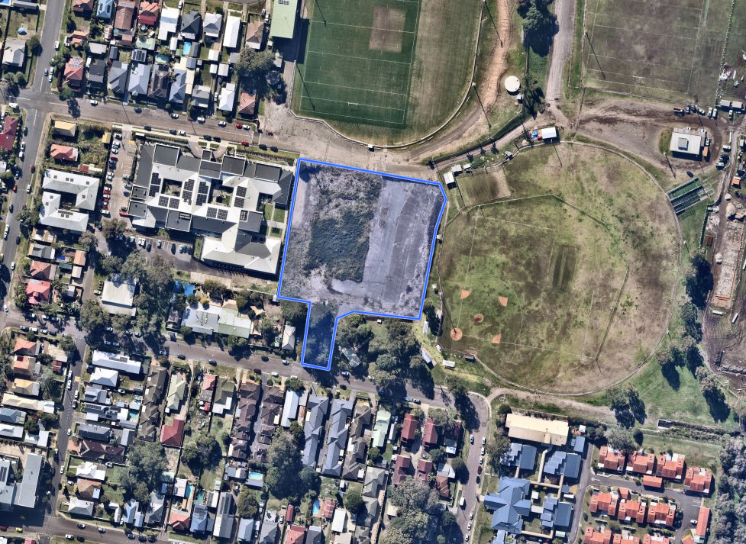
Figure 1: Aerial photo of site and surrounds
To the north and east of the site is the Belmont sports fields, which are open grassed fields with single-storey amenities building, and a small grand stand to one of the ovals.
Immediately west of the site is a single-storey seniors housing – residential care facility. Further west is a single-storey senior citizens centre and childcare centre.
A single residential dwelling sits south of the site adjacent the handle to Glover Street. Another seniors living development fronts the sports fields to the south.
Land to the south of Glover Street and north of Maude Street is zoned R3 Medium Density Residential. Several multi-dwelling housing developments exist, and there are a number of approvals that have been issued for residential flat building development which are yet to be constructed.
The R3 medium density residential zone permits development of up to six stories under the NSW state government’s Low and Mid-Rise Housing Policy. This is a key contextual change compared to when the development application was considered.
West of the site is a buffer of B4 Mixed Use zone before reaching the B2 Local Centre zone which comprises the Belmont Town Centre. Belmont Town Centre provides a full suite of day to day facilities, including supermarkets, medical facilities, library, cafes and restaurants, boutique shops, and professional services.
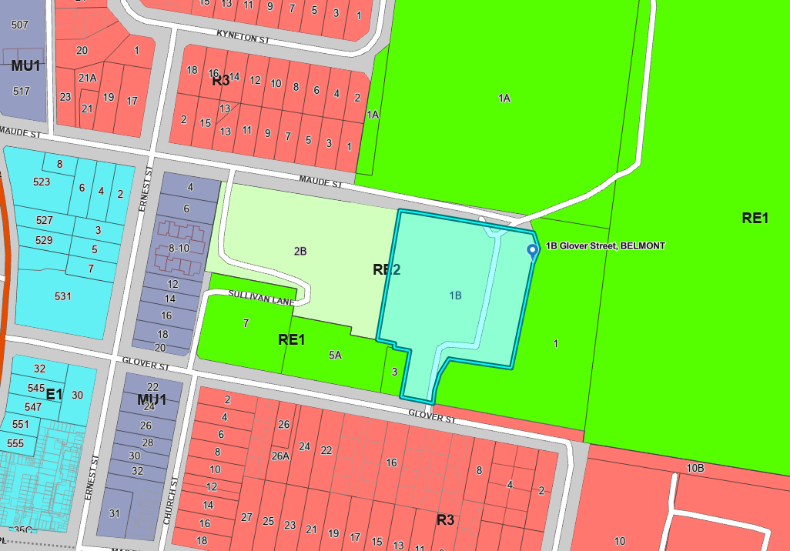
Figure 2: Zoning overlay of site and surrounds
Buses service Maude Street (200m) and Glover Street (90m), with additional options available on the Pacific Highway (300m).
The site is close to the centre of the Fernleigh Track network, a 30km north-south shared path providing access to Swansea, Belmont, Redhead, and connections into Newcastle.

- THE PROPOSAL AND BACKGROUND
  - The proposal
The proposal seeks consent for modification to the approved development for seniors housing.
Specifically, the modification proposes:
- an increase in maximum height of the building of 6.85 m, with the majority of the building increasing 3.5m. The proposed maximum height of the building is 17.75m above existing ground level (22.25m AHD).
Additions comprise one floor of additional apartments and one floor containing rooftop communal area, resulting in five stories total.
- Twenty-six additional dwellings resulting in a total of 101 dwellings.
- Thirty-two additional parking spaces in the basement and external area, resulting in a total provision of 127 car parking spaces.
Removal of one additional tree is proposed to accommodate the reconfiguration of the access driveway due to increased at-grade car parking.
- Minor amendments to facades and floor plans, signage, waste management, and balconies.
The key development data is provided in Table 1.
Table 1: Key development data
Control | Modified proposal
Site area | 9830m²
Max height | 17.75m
No. of apartments | 101
Landscaped area | Approx. 1825m²
Car parking spaces | 127 in total comprising 115 basement spaces and 12 external parking spaces.  This includes one EV ready in basement, 7 EV ready external, and two accessible spaces.
Setbacks | Maude Street (north) - 5.64m
Setbacks | East  - 5.7m-9.65m (terraces)  - 6m-11.2m (balconies)  - 9.9m-13.7m (walls)
Setbacks | West  - 7m-7.4m (terraces / balconies)  - 11.25m (wall)
Setbacks | Glover Street (south) - 48.3m

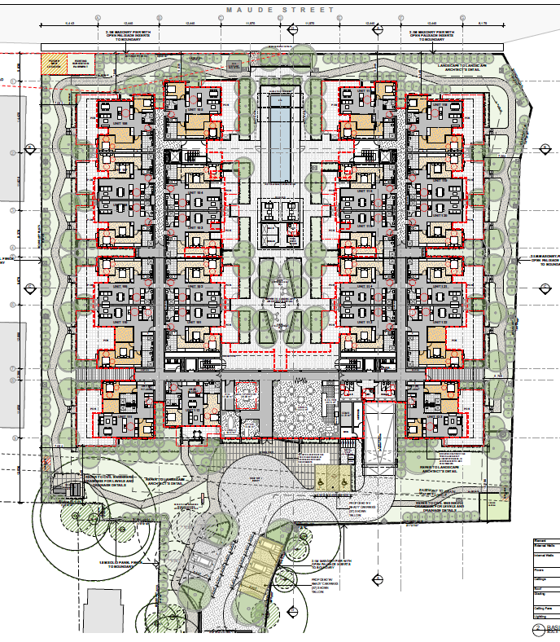
Figure 3: Amended ground floor plan
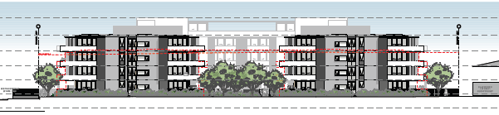
Figure 4: Amended north elevation
  - Background
The modification application was lodged on 21 May 2025. A chronology of the modification application since lodgement is outlined in Table 2.
Table 2: Chronology of the modification application
Date | Event
29 May 2025 | DA referred to internal officers
20 June 2025 | Exhibition of the application
9 July 2025 | DRP briefing
16 July 2025 | DA referred to external agencies
26 August 2025 | HCCRPP briefing
4 September 2025 | Request for information issued
2 October 2025 | Additional information submitted and referred to internal officers

  - Site history
The original application was approved by the HCCRPP Panel on 1 June 2022.
Physical commencement has been achieved as demolition has occurred in accordance with the consent.
- STATUTORY CONSIDERATIONS
When determining a modification application, the consent authority must take into consideration the matters outlined in 4.55(2) of the EP&A Act in relation to modification of consents provisions, Section 4.15(1) of the EP&A Act in relation to matters for consideration for applications and the Regulation in relation to information requirements and notification. These matters are considered below.
  - Section 4.55 of the EP&A Act
A consent authority may, on application being made by the applicant or any other person entitled to act on a consent granted by the consent authority and subject to and in accordance with the Regulations, modify the consent if a number of matters are satisfactorily addressed pursuant to Section 4.55(2) of the EP&A Act. The matters include the following:
- Substantially the same development
It is satisfied that the development to which the consent as modified relates is substantially the same development as the development for which consent was originally granted and before that consent as originally granted was modified (if at all) (s4.55(2)(a)), and
Council considers the development as modified is substantially the same as that originally approved, based on the following assessment.
- Quantitative assessment
The modified development will have two additional floors, comprising a maximum height increase of 6.85m (62.4%) above the development as approved and 77.5% above the applicable development standard. The uppermost level comprises approximately 15% of the floor plan, with the remainder of the rooftop sitting at 3.5m above approved levels (44.3% above the development standard).
The dwelling yield increases by 26 (35%) and carparking by 37 spaces (44.5%).
Landscape area is slightly reduced to accommodate additional at-grade carparking spaces.
- Qualitative assessment
The modified development retains the same land use and building typology as originally approved. The building materiality, floor plan and landscape design are largely unchanged.
Lift cores have been split to improve circulation and waste chutes have been included in the design.
Communal open space and rooms have been relocated from the ground floor to the rooftop terrace.
Conclusion
On the basis the development comprises the same land use, the same foot print, the same materiality, and the impacts arising from the development remain compliant with development controls, the development is considered to be substantially the same as originally approved despite the modifications.
- Consultation with public authorities
It has consulted with the relevant Minister, public authority or approval body (within the meaning of Division 4.8) in respect of a condition imposed as a requirement of a concurrence to the consent or in accordance with the general terms of an approval proposed to be granted by the approval body and that Minister, authority or body has not, within 21 days after being consulted, objected to the modification of that consent (s4.55(2)(b)), and
Council consulted with the following public authorities or approval bodies for the modification application:
- Ausgrid
- Subsidence Advisory NSW
- Water NSW
Each authority has responded to the consultation and none objected to the modification.
Subsidence Advisory NSW did not issue conditions of approval for the original consent. Conditions of approval have been issued for the modification application and have been included in the draft conditions of consent (Condition 4A).
Water NSW issued amended General Terms of Approval. The amended conditions have been included in the draft conditions of consent (Condition 4).
- Notification
it has notified the application in accordance with—
- the regulations, if the regulations so require, or
- a development control plan, if the consent authority is a council that has made a development control plan that requires the notification or advertising of applications for modification of a development consent (s4.55(2)(c)), and
The application was notified in accordance with Council’s Community Engagement Strategy (which includes the Community Participation Plan). The modification application was notified between 20 June 2025 and 11 July 2025.
- Submissions
it has considered any submissions made concerning the proposed modification within the period prescribed by the regulations or provided by the development control plan, as the case may be (Section 4.55(2)(d)).
No submissions were received.

Consideration of s4.15
In determining an application for modification of a consent under this section, the consent authority must take into consideration such of the matters referred to in section 4.15 (1) as are of relevance to the development the subject of the application. The consent authority must also take into consideration the reasons given by the consent authority for the grant of the consent that is sought to be modified (Section 4.55(3)).
The following matters were considered relevant under s4.15(1) of the EP&A Act and are addressed in detail in section 3.2.
Table 3: s4.15 key considerations
Environmental Planning Instruments | Assessment
State Environmental Planning Policies | As detailed in Section 3.2.1.
Lake Macquarie Local Environmental Plan 2014 | As detailed in Section 5 (building height)
Proposed instruments | A modification to the Lake Macquarie Local Environmental Plan 2014 had been publicly exhibited but not adopted at the time of lodgement of this application.  The subject matter of the amended plan is not relevant to this development
Development control plans | Assessment
Lake Macquarie Development Control Plan 2014 | As detailed in Section 3.2.1(c)
Matters for consideration | Assessment
The likely impacts of the development | The development as modified is considered to have minimal additional impact and remains suitable.
The suitability of the site | The site is considered suitable for the amended design.
Submissions | None received.

Reasons for the granting of consent
The determination letter issued by the HCCRPP noted the following reasons for the decision:
- The proposal contributes to housing diversity in an accessible location.
- The impacts of the development are reasonable and can be appropriately mitigated.
- The site is suitable for the scale and form of the development.
- The interfaces with adjoining development can be managed.
The development as modified remains consistent with the reasons for the granting of the original consent. The modified proposal continues to contribute to housing diversity in an accessible location. The impacts of the development as described in this report, including the interfaces with adjoining properties, continue to be reasonable and appropriately mitigated. The scale and form of the development has been supported by Council’s Design Review Panel.
  - Section 4.15(1) of the EP&A Act
Section 4.15(1) of the EP&A Act contains matters which the consent authority must take into consideration in determining a development application and modification applications pursuant to Section 4.55(3), which are of relevance to the application.
These matters include the following, which are considered in detail below:
- the provisions of—
- any environmental planning instrument, and
- any proposed instrument that is or has been the subject of public consultation under this Act and that has been notified to the consent authority (unless the Planning Secretary has notified the consent authority that the making of the proposed instrument has been deferred indefinitely or has not been approved), and
- any development control plan, and
(iiia) any planning agreement that has been entered into under section 7.4, or any draft planning agreement that a developer has offered to enter into under section 7.4, and
- the regulations (to the extent that they prescribe matters for the purposes of this paragraph),
that apply to the land to which the development application relates,
- the likely impacts of that development, including environmental impacts on both the natural and built environments, and social and economic impacts in the locality,
- the suitability of the site for the development,
- any submissions made in accordance with this Act or the regulations,
- the public interest.
    - Section 4.15(1)(a) - Provisions of Environmental Planning Instruments, Proposed Instruments, DCPs, Planning Agreements and the Regulations
The relevant provisions under s4.15(1)(a) are considered below.
- Environmental planning instruments (s4.15(1)(a)(i))
The following Environmental Planning Instruments (EPIs) are relevant to this application:
State Environmental Planning Policy (Housing) 2021
Chapter 3 Part 5 Housing for seniors and people with a disability
The original application was made prior to the commencement of SEPP (Housing) and was assessed under the former State Environmental Planning Policy (Housing for Seniors of People with a Disability) 2004. Permissibility for the development was obtained via LMLEP 2014 and the matters for assessment within the SEPP were addressed as guidance in the absence of a specific DCP.
Chapter 4 Design of residential apartment development
The application was referred to Council’s DRP, who provided support for the application. Advice on where the design may be improved was also included and has been addressed in the amended plans.
Council recommends the development meets the design quality principles outlined in the Apartment Design Guide.
State Environmental Planning Policy (Industry and Employment) 2021
The modification application seeks to include new building identification signage in addition to the signage approved under the original application.
Council has considered the assessment criteria for signage and recommends the proposed signage is appropriate and will have minimal environmental impact.
Table 4: assessment of new signage
Assessment criteria | Assessment
1. Character of the Area | The proposed sign identifies the operator of the facility and is located on the façade with the primary building entrance. The proposal is considered compatible with the desired future character of the area which is expected to have larger scale buildings with individualised identity inclusive of building naming or identification of the owner/occupant.
2. Special Areas | The sign will not be visible from the playing fields and could not be confused as relating to that facility.
3 Views and Vistas | The sign is located on the building façade and does not obscure any additional view.
4. Streetscape, Setting or Landscape | The sign is well set back from the road and is an appropriate scale to be read from that distance.
5. Site and Building | The sign is integrated into the design of the building and is appropriately scaled.
6. Associated Devices and Logos with Advertisements and Advertising Structures | N/A
7. Illumination | The signage is to be back lit. There is a low risk of the lighting causing nuisance.
8. Safety | The signage is not a safety risk.

State Environmental Planning Policy (Planning Systems) 2021
Section 2.19(1) and Clause 2 of Schedule 6 of State Environmental Planning Policy (Planning Systems) 2021 (SEPP Planning Systems) declares the proposal regionally significant development as general development over $30 million.
The modification application is referred to the HCCRPP in accordance with clause 275(2) of the Regulations as the modification application is 4.55(2) and seeks to:
- amend conditions imposed by the HCCRPP, and
- contravene a development standard imposed by an EPI by more than 10%.
As part of the determination of the original application conditions of consent were added by the HCCRPP in relation to electric vehicle charging requirements (conditions 24 and 93). The application seeks to amend the wording of these conditions.
The modification application is seeking additional height to the building, which would cause the development to contravene the development standard of 10m by 77.5%.
State Environmental Planning Policy (Resilience and Hazards) 2021
Chapter 4: Remediation of Land
The original development considered the status of contamination of the land and included conditions of consent and an approved remediation action plan in the original consent. The modification application does not seek amendment of the conditions applicable to contamination assessment and management.
State Environmental Planning Policy (Sustainable Buildings) 2022
The proposal is supported by a compliant BASIX certificate.
State Environmental Planning Policy (Transport and Infrastructure) 2021
The application was referred to Ausgrid as the relevant network operator in accordance with s2.48 development likely to affect an electricity distribution network.
Ausgrid did not object to the proposal. Comments provided by Ausgrid are matters which will be addressed through the CC submission.
Lake Macquarie Local Environmental Plan 2014
The proposal does not comply with the development standard/s in Part 4 of the LEP. This is considered in the key issues section of this report.
The proposal exceeds the height of buildings development standard of 10m applicable to the site (LMLEP Clause 4.3(2)). The proposed height of the building is 17.75m.
The proposal is considered to be otherwise consistent with the LEP.
- Provisions of any proposed instruments (s4.15 (1)(a)(ii))
A draft amendment to the LMLEP has been the subject of public consultation under the EP&A Act, however the subject of the change is not relevant to the proposal.
The amendment has commenced after the modification application was lodged.
- Provisions of any Development Control Plan (s4.15(1)(a)(iii))
The controls relevant to the proposal are considered in Table 5 below.
Table 5: Consideration of the DCP Controls
Part 9 – Specific land uses – Residential Flat Buildings
Control | Assessment
13.2 Housing mix | The housing mix remains compliant with the DCP controls.
13.7 Planting on structures | New planting has been included in planters on the roof top terrace. The design is compliant with the DCP controls.
13.10 Principle private open space | Each new dwelling is provided with compliant private open space by way of balconies. The redesigned balconies are compliant with required minimum areas.
13.12 Driveways and parking areas | The parking areas are considered suitable and can achieve required standards. Existing conditions of consent require confirmation of compliance with AS2890 at CC stage.
13.13 Adaptable dwellings | Each new dwelling meets adaptable requirements and achieves compliance with the DCP controls.
13.14 Operational waste management | The proposal includes waste chutes on each level separating waste into three streams for aggregation in 660L bins located in waste rooms at the basement level. One chute will divert both general waste and green waste.

- Planning agreements under Section 7.4 of the EP&A Act (s4.15(1)(a)(iiia))
There have been no planning agreements entered into and there are no draft planning agreements being proposed for the site.
- Provisions of Regulations (s4.15(1)(a)(iv))
Section 61 of the Regulation contains matters that must be taken into consideration by a consent authority in determining a development application, which includes demolition.
Demolition of the pre-existing building has already taken place.
    - Section 4.15(1)(b) - Likely impacts of development
The likely impacts of the development, including environmental impacts on both the natural and built environments, and social and economic impacts in the locality must be considered. In this regard, potential impacts related to the proposal have been considered in response to SEPPs, LEP and DCP controls outlined above and the Key Issues section below.
The development constitutes an appropriate built form for the context and the modified development will have minimal additional impact to the built and natural environment. The increased density close to the town centre is likely to have a positive economic impact.
Accordingly, it is considered that the proposed modification will not result in any significant adverse impacts in the locality.
    - Section 4.15(1)(c) - Suitability of the site
The site remains suitable for the amended proposal.
    - Section 4.15(1)(d) - Public Submissions
No submissions were received.
    - Section 4.15(1)(e) - Public interest
The proposed modification is considered to be in the public interest. The development will provide for additional housing for seniors in a well-located area close to services and amenities.
  - Development contributions
The development triggers additional development contributions under Council’s s7.11 contributions plan. Development contributions are due to be paid prior to the issue of the first CC and are currently owing. The amended value is to be updated in the conditions of consent (Condition 6).
- REFERRALS AND SUBMISSIONS
  - Agency referrals and concurrence
The modification application is integrated development. Accordingly, the modification application was referred to various agencies for comment as required by the EP&A Act and Regulations and outlined in Table 6.
There are no outstanding issues arising from these concurrence and referral requirements subject to the imposition of the recommended conditions of consent being imposed.
Table 6: Concurrence and referral agencies
Agency | Concurrence/referral Trigger | Comments (Issue, resolution, conditions) | Resolved
Concurrence requirements
Nil
Referral/consultation agencies
Electricity supply authority - Ausgrid | S2.48 of the State Environmental Planning Policy (Transport and Infrastructure) 2021 | No objections raised.  Comments provided relevant for consideration at CC stage. | Y
Integrated Development (s4.46 of the EP&A Act)
Subsidence Advisory NSW | S22 – Coal Mine Subsidence Compensation Act 2017  Approval to alter or erect improvements, or to subdivide land, within a mine subsidence district | Approval given with General Terms of Approval. | Y
Water NSW | S89-91 – Water Management Act 2000  Water use approval, water management work approval or activity approval under Part 3 of Chapter 3 | Approval given with General Terms of Approval. | Y

  - Council referrals
The modification application was referred to various Council officers for technical review as outlined Table 7. The outstanding issues raised by Council officers are considered in the Key Issues section of this report.
Table 7: Consideration of Council referrals
Officer | Comments | Resolved
Engineering | Council’s Engineering Officer reviewed the revised stormwater concept plan and car parking plans. There were no objections subject to compliance with existing conditions of consent. | Y
Landscape Architect | Council’s Landscape Architect has reviewed the revised plans, which include new planting on structure.  The landscape plans are considered satisfactory for development approval purposes.  Matters raised in the referral response are considered to be captured either in amended conditions of consent (Condition 54) or BCA compliance at CC stage. | Y
Arborist | The amended proposal is seeking the removal of one additional tree (tree No. 7) but includes the retention of a large high-amenity Norfolk Island pine (tree No. 8).  An arborist report and tree protection plan was submitted with the modification application.  The bulk earthworks plan notes trees for retention and refers to the arborist for requirements in the tree protection zone.  Existing conditions of consent remain appropriate for protection of retained trees. | Y
Accessibility | The modification application is supported by a suitable access audit which found the development capable of compliance with the BCA, AS 4299 and Liveable Housing Design guidelines.  Existing conditions of consent remain suitable. | Y
Waste | The waste referral noted a risk of odour and vermin where compostable bags break or leak before reaching the collection bin.  Council is unable to collect the proposed 660L bins, which would need to be serviced by a private contractor.  The proposal is substantially the same as the original consent with waste chutes extended to the new level. The proposal includes a reconfiguration of the diversion arrangements for the waste chutes.  The matters raised in the waste referral were considered in the original assessment and have not changed from the original consent. No changes or further action is recommended. | Y
Environmental management | A supplementary contamination assessment and updated remediation action plan were submitted with the application. The applicant has requested these documents be included as approved documents.  Council’s Environmental Officer has reviewed the Remediation Action Plan and supplementary contamination assessment and was supportive of the content.  Council recommends it is unnecessary to include the revised contamination reports in the approved document set as the documents act to satisfy existing conditions of consent and the existing conditions remain suitable. There are no changes to the suitability of the land for the proposed development. | Y
Transport | Council’s Transport Strategy officer has reviewed the application. It was noted the development as modified will generate additional foot traffic to the local commercial centre.  The existing consent specifies the construction of 1.5m wide footpath along Maude Street.  The approved plans show a new footpath section to be constructed along Glover Street where the existing driveway is to be removed. In accordance with existing condition 25, this section would be required to be 1.5m to meet Council’s current standard.  A further 8.5m of footpath exists on the western side of the driveway, and is at the old standard of 1.2m width. Should the footpath be damaged it would be expected to be repaired in accordance with existing Conditions 32, 72 and 73. | Y
Development contributions | The development triggers additional development contributions under Council’s s7.11 contributions plan. Development contributions are due to be paid prior to the issue of the first CC and are currently owing. The amended value is to be updated in the conditions of consent.  The original development pre-dates the Housing Productivity Contribution (HPC) and therefore the modification application is not subject to this levy. | Y

  - Notification and Community Consultation
The modification application was notified in accordance with the Council’s Community Participation Plan from 20 June 2025 until 11 July 2025. The notification included the following:
- Notification letters sent to adjoining and adjacent properties (twenty letters sent), and
- Notification on Council’s website.
No submissions were received in relation to this application.
- KEY ISSUES
The following key issues are relevant to the assessment of this application having considered the relevant planning controls and the proposal in detail.
5.1 Building height
The building form for the approved development is three storeys in height, with a variation to the 10m building height development standard of 0.928m (9.3%).
The modification application proposes new building form with a maximum height of 17.75m (77.5% variation).
The additional height is supported by Council.
The application has demonstrated minimal impact arises from the additional height, with the bulk of overshadowing falling on the subject lot. All adjoining lots receive compliant solar access. There are no additional view loss or overlooking arising from the proposal.
The context of the site has changed since the original approval, with the surrounding R3 Medium Density Residential land now permitted to have development up to six stories in height under the NSW State government Low and Mid Rise Housing Policy. While the policy does not apply to this site due to its zoning, the application is consistent with the intended outcomes for the adjoining land, and is consistent with the surrounding future context.
The application was referred to Council’s DRP. The DRP were supportive of the additional height, noting it created a better balance between the vertical and horizontal aspects of the built form. Amendments to the internal built form were recommended to address solar access to the development itself. The revised design has amended the balcony designs to achieve improved solar access.
5.2 Bulk and scale
The modified proposal is larger in bulk and scale than the original development, however is still considered to be acceptable and appropriate for the context of the development.
The development is well set back from the surrounding public roads and sits well in the context of public open space to the north and east.
The application was referred to Council’s DRP. The DRP were supportive of the additional built form, and recommended trees to be planted at the periphery of the site should be appropriately scaled to complement the building.
The amended plans result in retention of a mature Norfolk Island pine tree which complements the scale of the building and provides visual mitigation and amenity from commencement.
5.3 Traffic impact
The additional dwelling yield will result in additional traffic utilising local roads and intersections. A traffic impact assessment was submitted with the modification application. Local roads and intersections have capacity to accommodate the increased demand from the modified development. The traffic light-controlled intersection at Maude Street / Pacific Highway will require an upgrade by 2035 due to general development growth in the locality.
The original and modified applications do not trigger a referral to TfNSW for traffic generating development.
5.4 Tree removal and retention
The modified application originally sought the removal of three trees which were to be retained in the original approval, including a high-amenity Norfolk Island Pine.
The HCCPP briefing held in August 2025 identified the need to retain the Norfolk Island Pine due to its high amenity and contribution to mitigating building bulk and height.
The plans have been amended to allow for the retention of two of these trees, including the Norfolk Island Pine. Replacement tree planting included in the landscape plan can offset the residual tree loss.
5.5 Interface with sports fields
While the relocated car parking design results in the retention of significant amenity trees, it has a trade off in the loss of additional landscape area and increased impact arising from the interface with the public open space to the south.
Council recommends the impact is appropriate on balance, particularly as the impacted area is already set back from the main functional area of the playing fields and is slated to be further separated by a car park and relocation of the sports fields to the east under the adopted Belmont Sports Fields Master Plan (see figure 5).
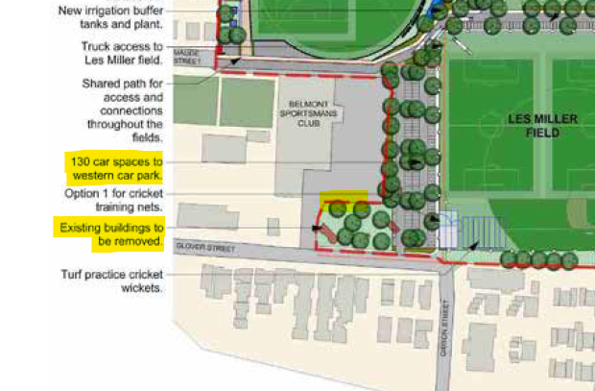
Figure 5: Extract from the adopted Belmont Sports Field Master Plan (page 15) showing the intended future use of the space affected by the interface change.
5.6 Car parking design
Council’s Engineer has reviewed the car parking design and recommended confirmation of compliance with AS2890 to be provided prior to the issue of a CC. This is included in existing conditions of consent.
5.7 Provision of electric vehicle charging infrastructure
Condition 24 of the original approval requires installation of ‘Level 2’ charging to 5% of the basement car parking spaces. This would result in four car parking spaces with charging available.
The application proposes to amend this condition to 5% of 127 spaces for the development to be ‘EV ready’, which can include car parking spaces within the basement or within the external car parking area. This would result in 6 spaces being ‘EV ready.’
Council does not have an electric vehicle charging policy which sets out the provision of required spaces, nor their configuration. However Council support the installation of this infrastructure as included in the original development, and proposed in the modification application.
To understand a reasonable outcome for this proposal, the applicant proposes the following based on their prior experience:
- Two operational fast chargers, located in the external parking bays, to be installed and operational at time of occupation of the development. These spaces will be available to residents and visitors. Chargers will be separately metered and “pay as you go”.
- Conduit to be installed to a further five external car parks for easy installation of additional chargers as demand dictates.
- A cable tray in the basement will allow for servicing of individual parking bays as required.
Council recommends the proposal achieves a pragmatic approach to satisfying electric vehicle charging demand while minimising the impact of future installation of additional chargers.
5.8 Waste management
Waste is proposed to be managed via waste chutes located on each level. The two chutes provide separation for recyclables in one chute, and a diverter which separates general and green waste in the other chute. 660L bins for each waste stream are located in the basement, where a bin tug is also stored to allow bins to be transferred between the basement aggregation point and the external storage and waste collection point.
The proposed management of waste is substantially similar to what has been approved, with minor changes to the configuration of the diverters and extension to the new floor.
Existing conditions of consent are considered appropriate with respect to waste management.
5.9 Panel comments from briefing
At the HCCPP briefing held in August 2025, the following matters were identified for further consideration:
- Retention of mature trees
Refer to consideration under Key Issues - 5.4 Tree removal and retention.
- Lifts to accommodate ambulance stretcher bed
The applicant has confirmed the lifts can accommodate an ambulance stretcher bed. The floor plans demonstrated this outcome can be achieved.
- Clarity on EV charging
Refer to consideration under Key Issues - 5.7 Provision of electric vehicle charging infrastructure.
- Location of BBQ and proximity to edge / private balconies
The BBQ has been separated from the edge of the building by a raised planter bed. This is an appropriate separation of the BBQ from the building edge.
- CONCLUSION
This modification application has been considered in accordance with the requirements of the EP&A Act and the Regulations as outlined in this report. Following a thorough assessment of the relevant planning controls and the key issues identified in this report, it is considered the application can be supported. Recommended draft conditions are provided at Attachment A.
- RECOMMENDATION
It is recommended:
- the modification application DA/2294/2021/A for seniors housing at 1B Glover Street Belmont be approved pursuant to Section 4.55(2) of the Environmental Planning and Assessment Act 1979, subject to the draft conditions of consent attached to this report at Attachment A, and
- pursuant to Clause 118 of the Environmental Planning and Assessment Regulation 2021, a notice of determination is to be prepared by Council following the HCCRPP’s determination of this modification application.

